**Vm 6.Demonstrate virtualization by Installing Type-2 Hypervisor in your device, create and configure VM image with a Host Operating system (Either Windows/Linux).**

STEP1:

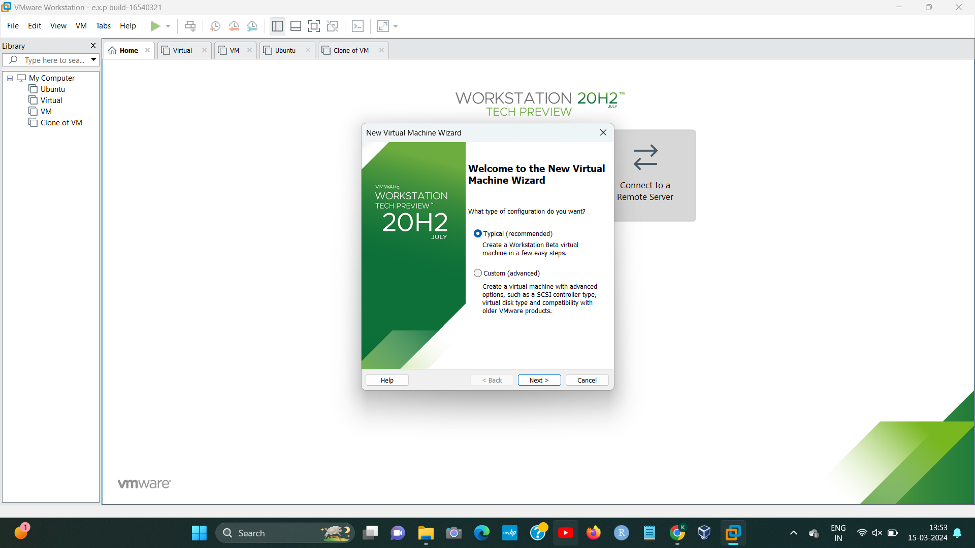

STEP2:

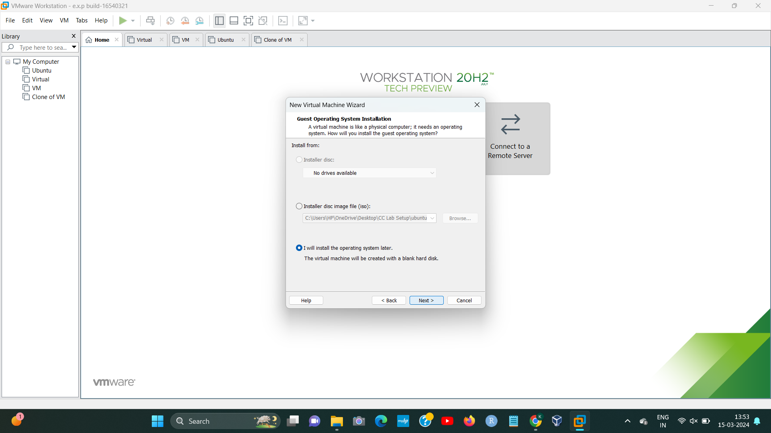

[1]

STEP3:

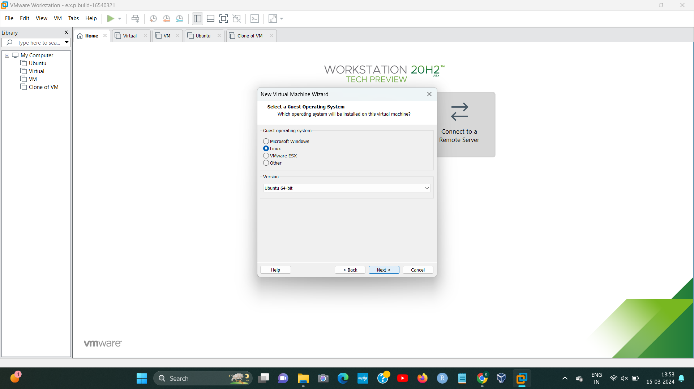

STEP4:

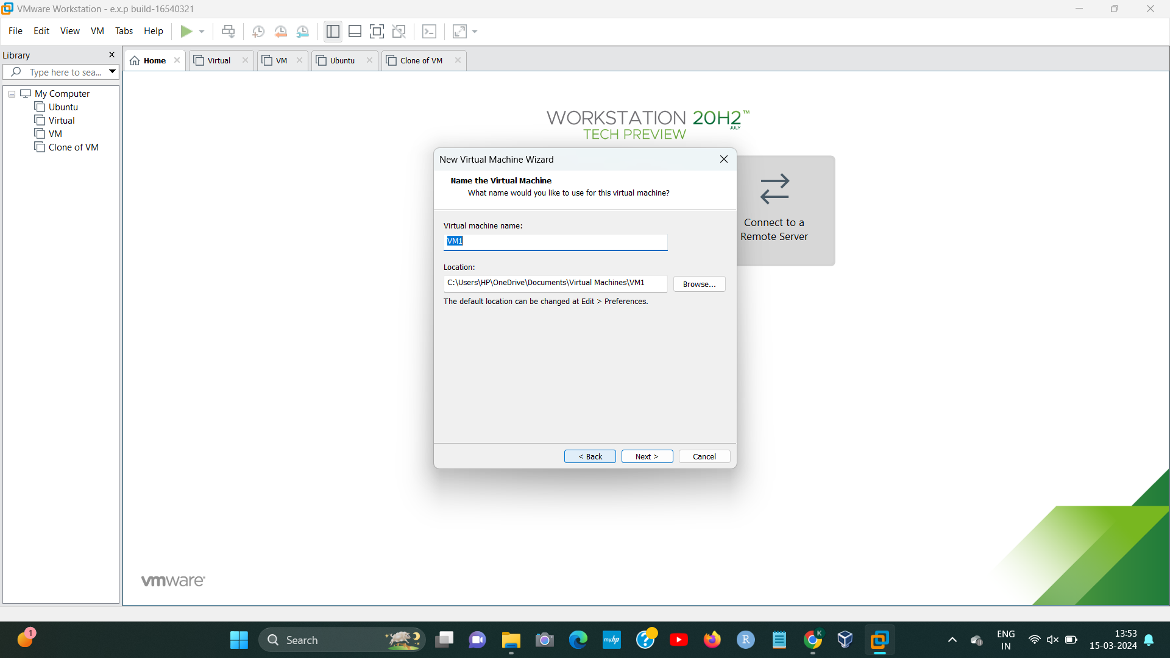

STEP5:

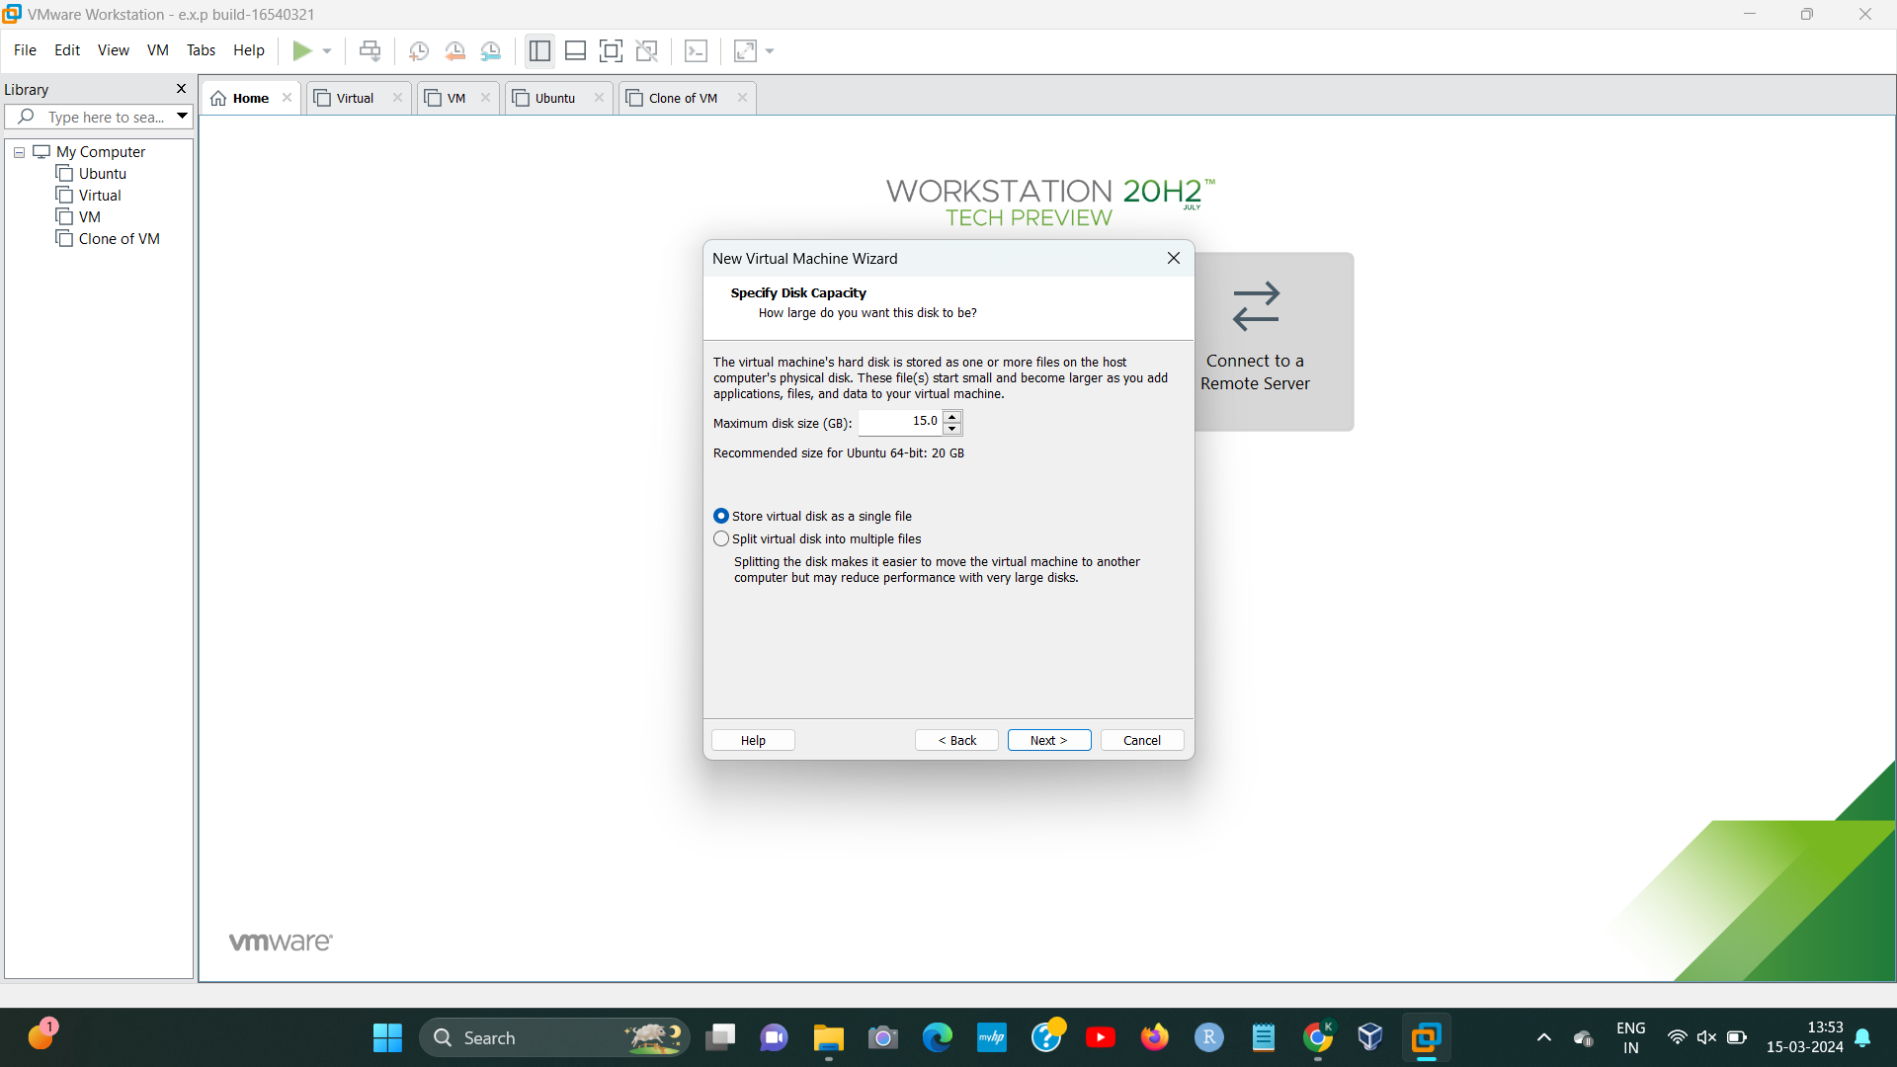

STEP6:

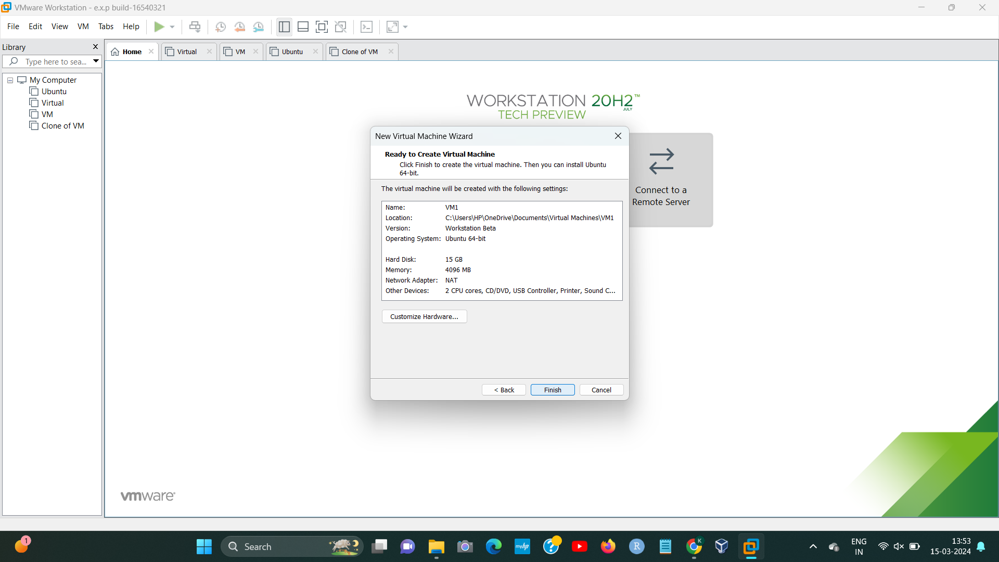

192224191 L.Kalyani

STEP7:

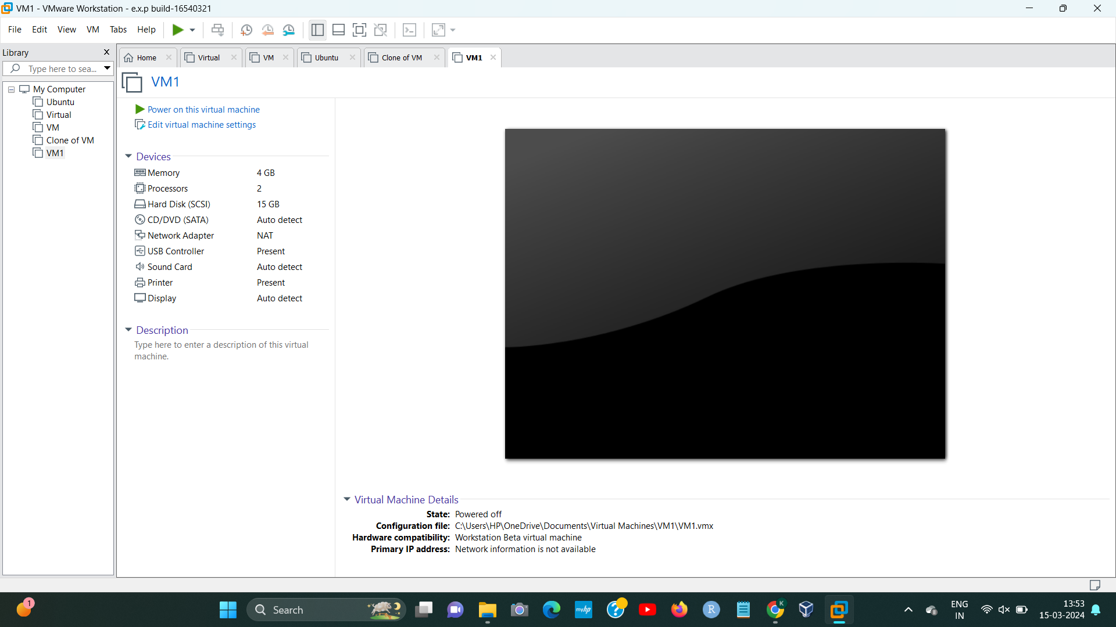[2]

1. 192224191 L.Kalyani
2. 192224191 L.Kalyani